Chapter 2, Solution 33

Combining the conductance leads to the equivalent circuit below
2S
1S
4S
4S
9A
+
v
-
i
1S
9A
+
v
-
i

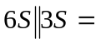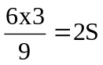 and 2S + 2S = 4S

Using current division,

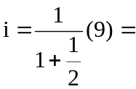 6 A, v = 3(1) = 3 V

